Spatial analysis of ship-strike risk for Rice’s whale in the Gulf of Mexico
Benjamin D. Best, Ph.D. (ben@ecoquants.com)
2024-02-25 15:23 (PST)
Contents

TODO: docx manual fixes
- ☐ Find ?(caption) instances and drop. Move table outside figure table if present (helps to turn on Paragraph marks). Place cursor just inside table, Reference > Insert Caption. Copy & paste from HTML output.
- ☐ Replace all missed gt table references ?@ with Table # hyperlink.
- ☐ Delete this heading and section, update ToC.
 Figure 1 corrected on 2023-11-25
Please note that Figure 1 has been updated on 2023-11-25. The layer of whale densities (Roberts et al. 2016) was previously not correctly projected and therefore misaligned with the original Whale Area (p. 292 of NMFS 2020). The raster layer has since been explicitly projected to the same as the basemap (Web Mercator; EPSG:3857) and now shows alignment with the original Whale Area.
Consolidation of duplicative paragraphs in Whale Densities corrected on 2024-02-21
These two paragraphs were consolidated from:
There was only a tiny marginal improvement in capturing additional whale densities by adding the 10 km buffer used to create the original Whale Area (pink outline in Figure 1). In generating the new Whale Area, the ease of navigation with simpler description in terms only of a southern limit and depth range outweighed this marginal improvement (red outline in Figure 2). This new Whale Area captures 94% of the population from the new density estimates (Litz et al. 2022) compared to only 52% of the original Whale Area (?@tbl-whales-by-area).
Adding the same 10 km buffer from the Biological Opinion (pink outline in Figure 1) to the 100-400m strip outlined in red in Figure 2, results in only a tiny marginal improvement in capturing whale densities (97% vs. 94%). For purposes of defining a new Whale Area in which vessel measures might apply, the benefit of ease of navigation, based on a simpler area description with only a southern limit and depth range defined, may outweigh this marginal improvement. This new Whale Area captures 94% of the densities derived from the new surface model (Litz et al. 2022), as compared to the much smaller proportion (52%) that would be captured within the original Whale Area (?@tbl-whales-by-area).
to:
This new Whale Area captures 94% of the densities derived from the new surface model (Litz et al. 2022), as compared to the much smaller proportion (52%) that would be captured within the original Whale Area (?@tbl-whales-by-area). Adding the same 10 km buffer from the original Biological Opinion (pink outline in Figure 1) to the 100-400m strip based on the newer density model (Litz et al. 2022) (red outline in Figure 2), results in only a tiny marginal improvement in capturing whale densities (97% with 10 km buffer vs. 94% without). For purposes of defining a new Whale Area in which vessel mitigation measures could apply, the benefit of ease of navigation, based on a simpler area description with only a southern limit and depth range defined, may outweigh this marginal improvement.
Clarified southern boundary of new Whale Area on 2024-02-25
OLD:
This new Whale Area captures 94% of the densities derived from the new surface model (Litz et al. 2022), as compared to the much smaller proportion (52%) that would be captured within the original Whale Area (?@tbl-whales-by-area).
NEW:
A new Whale Area was similarly formed by these 100- to 400-meter isobaths but now extends across to the western Gulf of Mexico. The southern boundary was defined by extracting the southern limit of the 90% contour around the new whale density surface (Litz et al. 2022). This new Whale Area captures 94% of the densities derived from the new surface model (Litz et al. 2022), as compared to the much smaller proportion (52%) that would be captured within the original Whale Area (?@tbl-whales-by-area).
For the R code used to calculate this southern limit from the 90% contour of the whale density layer, see prep.qmd#L701-L735.

1 Abstract
Since release of the Biological Opinion on oil and gas activities in the Gulf of Mexico (NMFS 2020) that used a published density surface model (Roberts et al. 2016) to describe the distribution of the critically endangered Rice’s whale (Balaenoptera ricei), a new density surface model (Litz et al. 2022) has been made available. Importantly, this model extends the distribution of Rice’s whale beyond its initial core habitat in the Eastern Gulf of Mexico to the West, where it had previously only been acoustically detected (Soldevilla et al. 2022). This report replicates the Biological Opinion’s ship-strike analysis using the newer Rice’s whale distributional model. Given the wider distribution of Rice’s whale, an alternative new Whale Area is suggested to reduce ship-strike risk with the Rice’s whale based simply on location (25.5º N and higher) and depth (100 to 400 m).

2 Background
Rice’s whale (Balaenoptera ricei, aka Gulf of Mexico whale) is a newly recognized species of baleen whale found only in the Gulf of Mexico (previously known as the Gulf of Mexico Bryde’s whale). It is considered Endangered under the U.S. Endangered Species Act and is classified as Critically Endangered on the IUCN Red List. The population size of the entire species was estimated to be only 33 individuals (Waring 2016) or 44 individuals (Rosel, Corkeron, Engleby, Epperson, et al. 2016a) using two different methods and is almost certainly under 100 individuals (Rosel, Corkeron, Engleby, Epperson, et al. 2016a). The species appears to be most abundant in the De Soto Canyon area of the northeastern Gulf of Mexico, but is also found persistently along the continental shelf break in the northwestern Gulf, off Louisiana and Texas (Soldevilla et al. 2022), which contains prey features important to the species (Kiszka et al. 2023). Major threats include risks from oil and gas exploration, oil spills, and ship strikes. The species appears to be especially vulnerable to ship strikes because of its coincidence with several active shipping routes and because these whales rest near the surface at night. The National Marine Fisheries Service conducted a spatial analysis of ship-strike risks for Rice’s whale (NMFS 2020) based on a spatial model of the density of Rice’s whales (Roberts et al. 2016) and on the spatial distribution of vessel traffic in the Gulf of Mexico. Spatial vessel traffic data (measured from vessel Automatic Identification System – AIS transmission) was extracted from publicly available sources by Jeffrey Adams (NMFS) and was gridded (expressed as kilometers of vessel transects per grid cell) to match the grid used in the spatial model of whale densities by Eric Patterson (NMFS). AIS vessel traffic data are typically only available for larger commercial vessels. Because whales are believed to be at particular risk of serious injury and death by faster vessels, the ship strike risk analysis was stratified by vessel speed. Because the analysis was particularly concerned with the impacts of vessels associated with the oil and gas industry, vessel traffic was also stratified by vessel type. The results were tabulated for 1) all vessels at all speeds, 2) all vessels travelling greater than 10 kts, 3) oil and gas vessels at all speeds, and 4) oil and gas vessels travelling greater than 10 kts. Ship-strike risk is assumed to be proportional to vessel traffic and whale abundance, so relative risk was estimated as the product of these two factors on a spatial grid, normalized relative to the maximum value (NMFS 2020). In May 2021, several organizations (Natural Resources Defense Council, Healthy Gulf, Center for Biological Diversity, Defenders of Wildlife, Earthjustice, and New England Aquarium) petitioned the National Marine Fisheries Service to institute a mandatory vessel speed limit (10 kts) and other measures to protect Rice’s whale in its core habitat. That core habitat was defined as the waters between 100 m and 400 m deep from approximately Pensacola, FL, to just south of Tampa, FL (i.e., from 87.5° W to 27.5° N) plus an additional 10 km around that area. This area generally corresponds to the earlier BIA designation and the Bryde’s whale mitigation area defined in NMFS 2020.
Since that time, new analyses of ship and aircraft survey data from 2012 to 2019 (Litz et al. 2022) predict a higher density of Rice’s whale to the west of the core habitat than was predicted by the previous density model (Roberts et al. 2016). Recent acoustic data also confirmed the presence of Rice’s whale west of their core habitat (Soldevilla et al. 2022). Because the density of vessel traffic is much higher west of the core habitat, the actual ship-strike risk for Rice’s whale may be highest outside their previously identified core habitat (referred to hereafter as the “original Whale Area”). This report calculates the spatial risk of ship strikes to Rice’s whale based on this more recent model of their density distribution using the same methods and data employed in NMFS’s Biological Opinion (NMFS 2020).

3 Whale Densities
The new density surface model (Litz et al. 2022) uses approximately 40 km² hexagons as its spatial unit to describe number of individuals per 40 km² in a Lambert Conformal Conic projection, whereas the original whale density model (Roberts et al. 2016) used 100 km² cells in a custom equal area Albers projection to describe number of individuals per 100 km². The new ship-strike risk analysis also uses 100 km² cells to be most similar to the AIS data set used in the Biological Opinion. These cells appear in the web Mercator projection (EPSG:3857), which allows for easy online mapping of results using the Esri Ocean Basemap, a common “slippy” basemap. All layers were clipped to the study area of the U.S. Exclusive Economic Zone (EEZ) within the Gulf of Mexico.
Normally converting polygons to raster extracts only the centroid point of the raster cell from the underlying polygon. To capture the entirety of the underlying geometric densities, a vector-based intersection was first performed on all layers (whale hexagons, ship cells, and new units) before summarizing to the raster cell as area-weighted means.
To adjust for slight differences from projecting coordinate reference systems and for rounding errors, the new 100 km² whale density surface grid that re-projects the most recent density surface model (Litz et al. 2022) was adjusted so that the sum of individuals predicted throughout the study area is equal to 51.3, the most recent abundance estimate (Garrison, Ortega-Ortiz, and Rappucci 2020). That abundance estimate includes the most recent marine mammal survey data used by the new density model (Litz et al. 2022).
Compared to their distribution under the outdated density surface model (Figure 1), the whales now appear concentrated along the strip from 100 to 400 m extending into the Western Gulf of Mexico (Figure 2).
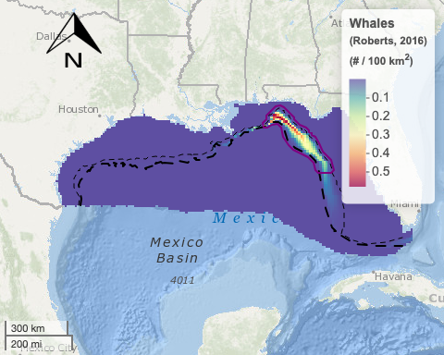
Figure 1: Map of previous whale densities (Roberts et al. 2016) as 100 km² cells used by (NMFS 2020) showing the dominance in the northeastern corner of the Gulf of Mexico. The original Whale Area (p. 292 of NMFS 2020) is depicted by the pink outline polygon for vessel slowdown and nighttime avoidance. Depth contours are shown in dash blacked lines for 100 m (finer) and 400 m (thicker).
The original Whale Area (pink outline in Figure 1) — the habitat area that, pursuant to the Biological Opinion, was subject to vessel speed limits and other measures — was defined in the Biological Opinion (p. 292 of NMFS 2020) as follows:
…the area from 100- to 400-meter isobaths from 87.5° W to 27.5° N as described in the status review (Rosel, Corkeron, Engleby, Epperson, et al. 2016b) plus an additional 10 km around that area.
A new Whale Area (red outline in Figure 2) was similarly formed by these 100- to 400-meter isobaths but now extends across to the western Gulf of Mexico. The southern boundary was defined by extracting the southern limit of the 90% contour around the new whale density surface (Litz et al. 2022). This new Whale Area captures 94% of the densities derived from the new surface model (Litz et al. 2022), as compared to the much smaller proportion (52%) that would be captured within the original Whale Area (?@tbl-whales-by-area). Adding the same 10 km buffer from the original Biological Opinion (pink outline in Figure 1) to the 100-400m strip based on the newer density model (Litz et al. 2022) (red outline in Figure 2), results in only a tiny marginal improvement in capturing whale densities (97% with 10 km buffer vs. 94% without). For purposes of defining a new Whale Area in which vessel mitigation measures could apply, the benefit of ease of navigation, based on a simpler area description with only a southern limit and depth range defined, may outweigh this marginal improvement.
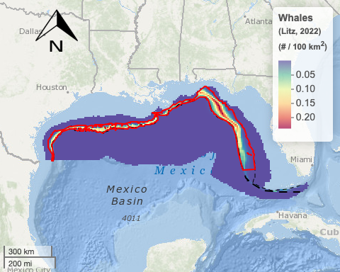
Figure 2: Map of new whale densities (Litz et al. 2022) as 100 km² cells showing a distribution throughout the region. The newly recommended Whale Area is depicted by the red outline polygon for vessel slowdown and nighttime avoidance using similar logic as to (NMFS 2020). Depth contours are shown in dash blacked lines for 100 m (finer) and 400 m (thicker).
Item | # | %
Whales in Study (U.S. Gulf of Mexico) | 51 | 100%
Whales in Original Whale Area (NMFS, 2020) | 27 | 52%
Whales in New Whale Area | 48 | 94%
?(caption)

4 Vessel Traffic
In order to evaluate the threat of ship-strike to Rice’s whales, we used the same AIS data from 2014 to 2018 as the Biological Opinion (NMFS 2020). This data is based on a grid of cells ~126 km² in Albers equal area projection. Traffic in terms of kilometers (km) traversed within a cell was differentiated based on speed (≤ 10 knots or > 10 knots) and type (oil & gas or all types). In order to produce maps similar to the original Biological Opinion (NMFS 2020) showing spatial variation, colors were assigned to the Jenks natural breaks of the distribution of values (Figures 3, 4, 5, 6).
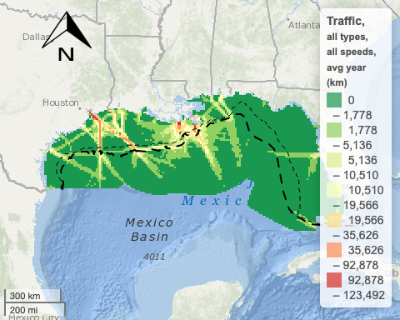
Figure 3: Map of annual average traffic (km) for all vessel types at all speeds from AIS data (2014 to 2018). Depth contours are shown in dash blacked lines for 100 m (finer) and 400 m (thicker).

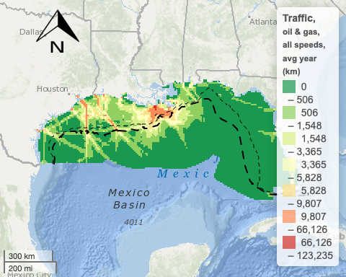
Figure 4: Map of annual average traffic (km) for oil and gas vessels at all speeds from AIS data (2014 to 2018). Depth contours are shown in dash blacked lines for 100 m (finer) and 400 m (thicker).

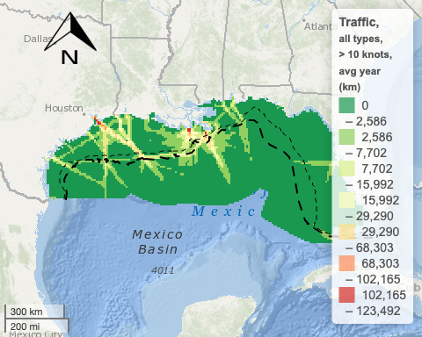
Figure 5: Map of annual average traffic (km) for all vessel types > 10 knots from AIS data (2014 to 2018). Depth contours are shown in dash blacked lines for 100 m (finer) and 400 m (thicker).

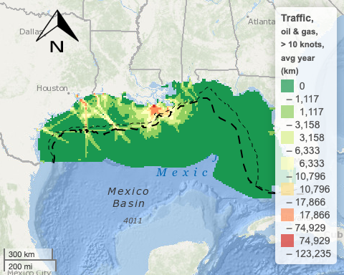
Figure 6: Map of annual average traffic (km) for oil and gas vessels > 10 knots from AIS data (2014 to 2018). Depth contours are shown in dash blacked lines for 100 m (finer) and 400 m (thicker).

5 Vessel Risk to Whales
Following the methodology employed in the Biological Opinion, the vessel risk ($R$) to whales is calculated here as a simple multiplication of number of whales ($W$) and km of vessel traffic ($V$) (Equation 1) for each spatial cell.
$$R=W*V \left(1\right)$$
This risk ($R$) can be further differentiated by vessel ($V$) type and speed (Figures 7, 8; Table ?@tbl-risk-overview).
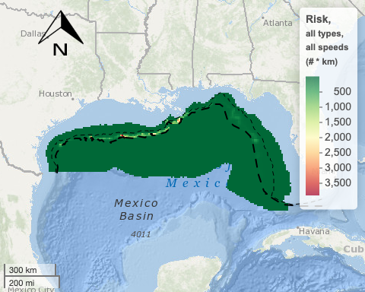
Figure 7: Map of risk (# whales * km vessel traffic) for all vessels at all speeds. Depth contours are shown in dash blacked lines for 100 m (finer) and 400 m (thicker).

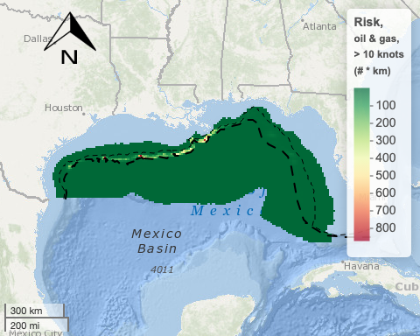
Figure 8: Map of risk (# whales * km vessel traffic) for oil and gas vessels > 10 knots. Depth contours are shown in dash blacked lines for 100 m (finer) and 400 m (thicker).
 | Vessel Strike Risk
Year | All Vessels | Oil & Gas | %
All speeds
2015 | 92,849 | 38,428 | 41%
2016 | 85,323 | 33,280 | 39%
2017 | 86,236 | 33,858 | 39%
2018 | 100,326 | 38,668 | 39%
Avg | 91,183 | 36,059 | 40%
> 10 knots
2015 | 71,621 | 23,153 | 32%
2016 | 67,878 | 21,519 | 32%
2017 | 68,494 | 21,909 | 32%
2018 | 79,759 | 25,209 | 32%
Avg | 71,938 | 22,948 | 32%
?(caption)
Finally, we can evaluate the risk reduction of the original Whale Area proposed in the Biological Opinion (NMFS 2020) compared with the newly proposed Whale Area, when the new density surface model is used (?@tbl-risk-reduction-by-areas). As can be seen, the newly proposed Whale Area is associated with substantially greater risk reduction than the original Whale Area, regardless of vessel type (oil & gas or all types) and speed (> 10 knots or all speeds).
 | Risk Reduction by Whale Area
Year | Original | % | New | %
All speeds - All vessels
2015 | 11,025 | 12% | 86,016 | 93%
2016 | 10,963 | 13% | 79,186 | 93%
2017 | 10,343 | 12% | 80,252 | 93%
2018 | 11,956 | 12% | 93,215 | 93%
Avg | 11,072 | 12% | 84,667 | 93%
All speeds - Oil & Gas vessels
2015 | 2,516 | 3% | 34,977 | 38%
2016 | 1,827 | 2% | 30,287 | 35%
2017 | 2,175 | 3% | 31,073 | 36%
2018 | 1,520 | 2% | 35,309 | 35%
Avg | 2,010 | 2% | 32,911 | 36%
> 10 knots - All vessels
2015 | 7,842 | 11% | 66,483 | 93%
2016 | 8,194 | 12% | 63,161 | 93%
2017 | 7,644 | 11% | 63,856 | 93%
2018 | 9,105 | 11% | 74,307 | 93%
Avg | 8,196 | 11% | 66,952 | 93%
> 10 knots - Oil & Gas vessels
2015 | 949 | 1% | 21,089 | 29%
2016 | 659 | 1% | 19,655 | 29%
2017 | 721 | 1% | 20,145 | 29%
2018 | 450 | 1% | 23,116 | 29%
Avg | 695 | 1% | 21,001 | 29%
?(caption)

6 Reproducible Results
This report was produced using the principles of reproducible research (Lowndes et al. 2017) with the R programming language (R Core Team 2023). Statistical analysis were performed using the libraries and methods of the tidyverse (Wickham et al. 2019) and spatial features sf (Pebesma 2018) output to a Quarto document (Allaire 2022). All source code is available in the Github repository github.com/ecoquants/ricei. The interactive version of this report is available at ecoquants.com/ricei.

7 Acknowledgements
This report received funding from Earthjustice. The AIS data used in (NMFS 2020) were provided by NMFS pursuant to a Freedom of Information Act request. A portion of the background section was contributed by Jay Barlow. Steve Mashuda (Earthjustice) and Michael Jasny (NRDC) reviewed drafts of the report.

References
Allaire, J. 2022. “Quarto: R Interface to’Quarto’Markdown Publishing System.” R Package Version 1.
Garrison, Lance, Joel Ortega-Ortiz, and Gina Rappucci. 2020. “Abundance of Marine Mammals in Waters of the U.S. Gulf of Mexico During the Summers of 2017 and 2018.” PRBD-2020-07.
Kiszka, Jeremy J., Michelle Caputo, Johanna Vollenweider, Michael R. Heithaus, Laura Aichinger Dias, and Lance P. Garrison. 2023. “Critically Endangered Rice’s Whales (Balaenoptera Ricei) Selectively Feed on High-Quality Prey in the Gulf of Mexico.” Scientific Reports 13 (1): 6710. https://doi.org/10.1038/s41598-023-33905-6.
Litz, Jenny, Laura Aichinger Dias, Gina Rappucci, Anthony Martinez, Melissa Soldevilla, Lance Garrison, and Keith Mullin. 2022. “Cetacean and Sea Turtle Spatial Density Model Outputs from Visual Observations Using Line-Transect Survey Methods Aboard NOAA Vessel and Aircraft Platforms in the Gulf of Mexico.”
Lowndes, Julia S. Stewart, Benjamin D. Best, Courtney Scarborough, Jamie C. Afflerbach, Melanie R. Frazier, Casey C. O’Hara, Ning Jiang, and Benjamin S. Halpern. 2017. “Our Path to Better Science in Less Time Using Open Data Science Tools.” Nature Ecology & Evolution 1 (6): 1–7. https://doi.org/10.1038/s41559-017-0160.
NMFS. 2020. “‘Biological Opinion on the Federally Regulated Oil and Gas Program Activities in the Gulf of Mexico,’ 13 March 2020, a Consultation Conducted by the Endangered Species Act Interagency Cooperation Division, Office of Protected Resources, National Marine Fisheries Service, National Oceanic and Atmospheric Administration, U.S. Department of Commerce.”
Pebesma, Edzer. 2018. “The R Journal: Simple Features for R: Standardized Support for Spatial Vector Data.” The R Journal 10 (1): 439–46. https://doi.org/10.32614/RJ-2018-009.
R Core Team, R. 2023. “R: A Language and Environment for Statistical Computing.” Vienna, Austria.
Roberts, Jason J., Benjamin D. Best, Laura Mannocci, Ei Fujioka, Patrick N. Halpin, Debra L. Palka, Lance P. Garrison, et al. 2016. “Habitat-Based Cetacean Density Models for the U.S. Atlantic and Gulf of Mexico.” Scientific Reports 6 (March): 22615. https://doi.org/10.1038/srep22615.
Rosel, Patricia E., P. J. (Peter James) Corkeron, Laura Engleby, Deborah M. Epperson 1965-, Keith (Keith D.) Mullin, Melissa S. Soldevilla, and Barbara Louise Taylor 1954-. 2016a. “Status Review of Bryde’s Whales (Balaenoptera Edeni) in the Gulf of Mexico Under the Endangered Species Act.” Edited by Southeast Fisheries Science Center (U.S.), NOAA technical memorandum NMFS-SEFSC ; 692,. https://doi.org/10.7289/V5/TM-SEFSC-692.
Rosel, Patricia E., Peter Corkeron, Laura Engleby, Deborah Epperson, Keith D. Mullin, Melissa S. Soldevilla, and Barbara L. Taylor. 2016b. “Status Review of Bryde’s Whales (Balaenoptera Edeni) in the Gulf of Mexico Under the Endangered Species Act,” 32.2 MB. https://doi.org/10.7289/V5/TM-SEFSC-692.
Soldevilla, Melissa S., Amanda J. Debich, Lance P. Garrison, John A. Hildebrand, and Sean M. Wiggins. 2022. “Rice’s Whales in the Northwestern Gulf of Mexico: Call Variation and Occurrence Beyond the Known Core Habitat.” Endangered Species Research 48 (July): 155–74. https://doi.org/10.3354/esr01196.
Waring, Gordon T. (ed.) et al. 2016. “US Atlantic and Gulf of Mexico Marine Mammal Stock Assessments - 2015.” Edited by Northeast Fisheries Science Center (U.S.), NOAA technical memorandum NMFS-NE ; 238,. https://doi.org/10.7289/V57S7KTN.
Wickham, Hadley, Mara Averick, Jennifer Bryan, Winston Chang, Lucy D’Agostino McGowan, Romain François, Garrett Grolemund, et al. 2019. “Welcome to the Tidyverse.” Journal of Open Source Software 4 (43): 1686. https://doi.org/10.21105/joss.01686.

